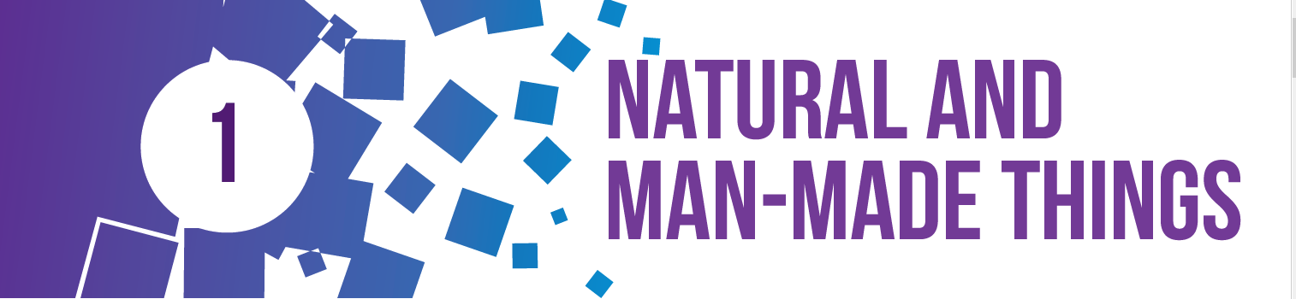


1. Fill in the blanks.

Ans. a. Machine
b. Computer
c. Electricity

2. Fill in the missing letters.

Ans. a) T R E E
b) C O M P U T E R
c) T A B L E F A N
d) R E F R I G E R A T O R

3. Write True or False.

Ans. a) True
b) False
c) True


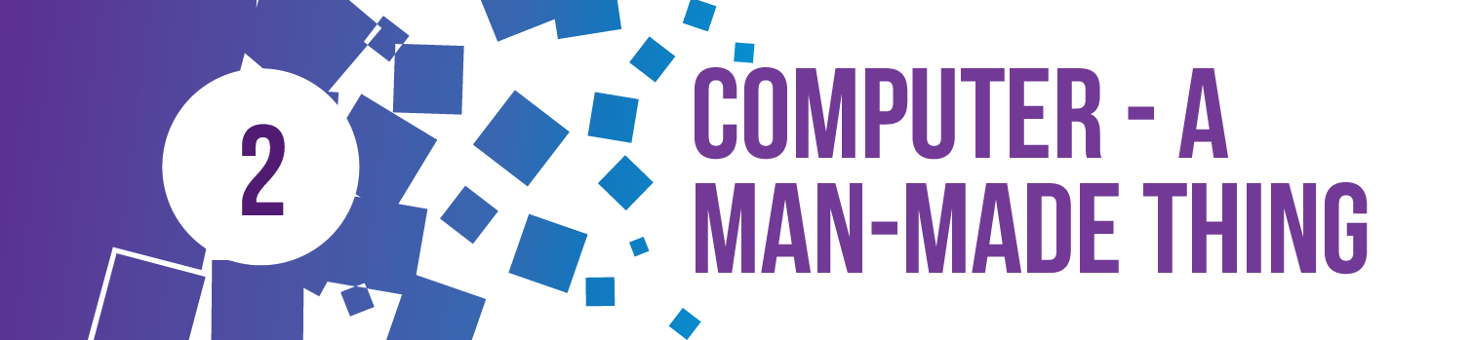

1. Fill in the blanks.

Ans. a) electronic
b) desktop
c) tablet
d) rechargeable

2. Write True or False.

Ans. a) False
b) False
c) True
d) True



1. Name the following.

Ans. a) printer
b) monitor
c) mouse
d) CPU

2. Name the parts of the computer displayed below.

Ans. From left to right:
1. Scanner 2. Printer
3. Speakers 4. Keyboard
5. Monitor 6. Mouse
7. Mike 8. CPU

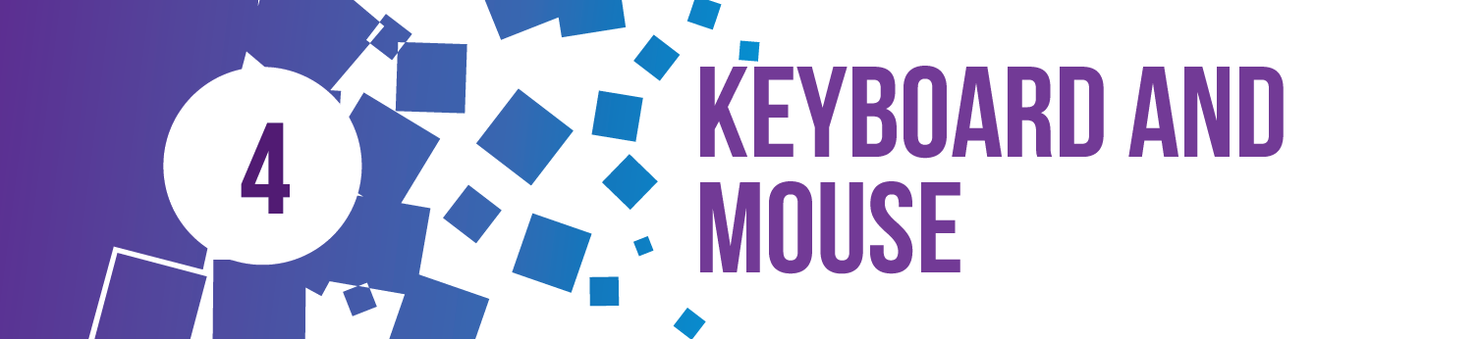

1. Fill in the blanks.

Ans. a) keyboard
b) Caps Lock
c) Enter
d) Backspace

2. Rearrange the letters.

Ans. a) KEYBOARD
b) SPACEBAR
c) ENTER
d) NUMBER



1. Fill in the blanks:

Ans. a) Windows 10
b) Start
c) Power



1. Fill in the blanks.

Ans. 1) Center
2) Working area
3) Rich text document

2. Fill in the missing letter.

Ans. a) W O R D P A D
b) FO N T
c) I T A L I C S

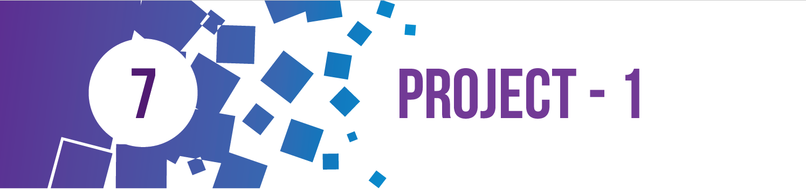

1. Fill in the blanks.

Ans. 1. Man-Made
2. Double
3. Scanner
4. Right
5. Electronic
6. Windows



1.Fill in the blanks.

Ans. a) WordPad
b) Insert
c) Bold

2. Write True or False.

Ans. a) True
b) False
c) True
d) True



1. Match the following:

Ans. 1. b 2. d 3. a 4. c

2. Write True or False.

Ans. a) True
b) False
c) True
d) False

3. Name the storage device.

Ans. 1) CD
2) Pen drive
3) Hard Disk

4. Colour the balloons that are storage devices.

Ans. 2nd , 4th and 5th balloon to be coloured.



1. Fill in the blanks.

Ans. a) Input
b) processes
c) speakers
d) Output

2. Write True or False.

Ans. a) False
b) False
c) True
d) True



1. Fill in the blanks.

Ans. a) Application Software
b) MS Office 2016
c) Excel 2016

2. Match the following.

Ans. 1. c 2. a 3. b



1. Fill in the blanks.

Ans. a) Microsoft Edge
b) Address bar
c) Internet

